***TEVFIK OZGU***

***150180082***

***a-) Draw the truth table for the Circuit a.***

***X $A_{4}$ $B_{4}$ C $O_{p}$ $R_{4}$ Overflow***

*0 0 0 0 0 0 0*

*0 0 0 1 0 Φ 1*

*0 0 1 0 1 1 0*

*0 0 1 1 1 0 0*

*0 1 0 0 1 0 0*

*0 1 0 1 1 1 0*

*0 1 1 0 0 1 0*

*0 1 1 1 0 Φ 1*

*1 0 0 0 1 1 0*

*1 0 0 1 1 0 0*

*1 0 1 0 0 0 0*

*1 0 1 1 0 Φ 1*

*1 1 0 0 0 1 0*

*1 1 0 1 0 Φ 1*

*1 1 1 0 1 0 0*

*1 1 1 1 1 1 0*

***TEVFIK OZGU***

***150180082***

***Write the simplest expression for the outputs Op, Sign, and Overflow.***

***Karnaugh Map Of $O_{p}$:***

$B_{4}C$

***X $A_{4}$ 00 01 11 $B_{4}$ 10***

|  |  |  |  |
| --- | --- | --- | --- |
|  |  | *1* | *1* |
| *1* | *1* |  |  |
|  |  | *1* | *1* |
| *1* | *1* |  |  |

***00***

***01***

$A_{4}$

***11***

***X***

***10***

*C*

***Simplest Expression of $O_{p}$ is X $A_{4}B_{4}$ + X $A_{4}B_{4}$ + X $A_{4}B_{4}$ + X $A_{4}B_{4}$.***

***TEVFIK OZGU***

***150180082***

***Karnaugh Map Of $Sign$:***

$B_{4}C$

***X $A_{4}$ 00 01 11 $B_{4}$ 10***

|  |  |  |  |
| --- | --- | --- | --- |
|  | *Φ* |  | *1* |
|  | *1* | *Φ* | *1* |
| *1* | *Φ* | *1* |  |
| *1* |  | *Φ* |  |

***00***

***01***

$A_{4}$

***11***

***X***

***10***

***C***

***Simplest Expression of Sign is X $CB_{4}$ + X $CB_{4}$ + C $A_{4}$.***

***TEVFIK OZGU***

***150180082***

***Karnaugh Map Of $Overflow$:***

$B_{4}C$

***X $A_{4}$ 00 01 11 $B_{4}$ 10***

|  |  |  |  |
| --- | --- | --- | --- |
|  | *1* |  |  |
|  |  | *1* |  |
|  | *1* |  |  |
|  |  | *1* |  |

***00***

***01***

$A_{4}$

***11***

***X***

***10***

***C***

***Simplest Expression of Overflow is X $A_{4}B_{4}C$ + X $A_{4}B_{4}C$ +X $A_{4}B_{4}C$ + X $A_{4}B_{4}C$.***

***TEVFIK OZGU***

***150180082***

***Draw the circuit a using any type of logic gates. Fully label all input and outputs.***

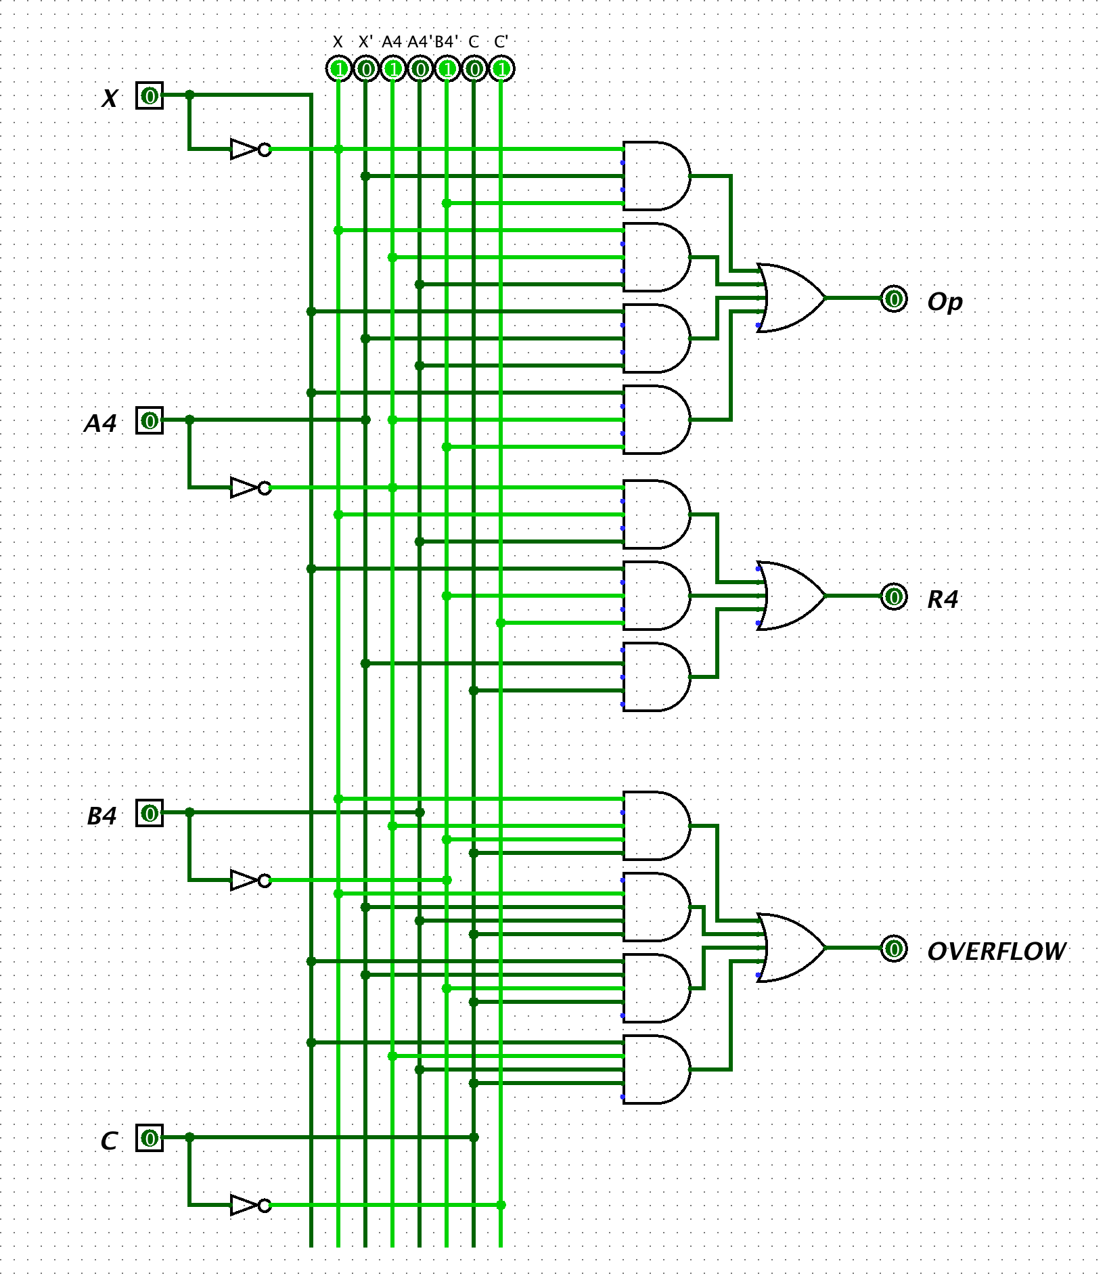

***TEVFIK OZGU***

***150180082***

***b)*** ***Design and draw the Circuit c using only half adders and minimum number of logic gates. Fully label all input and outputs.***

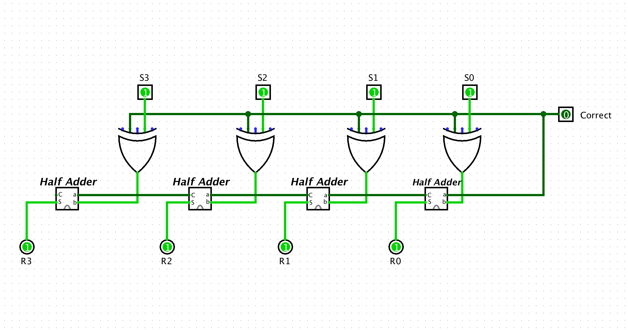

***c) Design and draw the Circuit d using any type of logic gates. Fully label all input and outputs.***

